10th Sunday After Pentecost

August 17, 2025

www.riverofhopehutchinson.org

Worship on Facebook Premiere, Sundays at 10:30am

Gathering

Music to Prepare Us For Worship

Opening Song “Vagabonds”

Welcome * Welcome Pads * Post it Notes *

[This Photo](https://www.flickr.com/photos/oxfordshire_church_photos/413448324) by Unknown Author is licensed under [CC BY](https://creativecommons.org/licenses/by/3.0/)

(Leader): *Wherever you are on your journey of faith,  we believe God meets you right where you are, and you are welcome here.*

Greeting

(Leader): *The grace of our Lord Jesus Christ, the love of God, and the community of the Holy Spirit is with you all.* **And also with you.**

**Confession**

Blessed be the holy Trinity,☩ one God,

whose steadfast love endures forever.

**Amen.**

Let us confess our sin in the presence of God and of one another.

*Silence is kept for reflection.*

Merciful God,

**we confess that we have not followed your path**

**but have chosen our own way.**

**Instead of putting others before ourselves,**

**we long to take the best seats at the table.**

**When met by those in need,**

**we have too often passed by on the other side.**

**Set us again on the path of life.**

**Save us from ourselves**

**and free us to love our neighbors.**

**Amen.**

Hear the good news!

God does not deal with us according to our sins

but delights in granting pardon and mercy.

In the name of ☩ Jesus Christ, your sins are forgiven.

You are free to love as God loves. **Amen.**

Prayer of the Day

Let us pray,

**O God, judge eternal, you love justice and hate oppression, and you call us to share your zeal for truth. Give us courage to take our stand with all victims of bloodshed and greed, and, following your servants and prophets, to look to the pioneer and perfecter of our faith, your Son, Jesus Christ, our Savior and Lord.  Amen.**

Greet Someone New *Music to Bring Us Back Together:* “Vagabonds” Chorus / Coda

Children’s Time

**The Word**

(Reader): *Our story and God’s story continues today with two readings. You are invited to follow along in your Bibles for our first reading from the book of Hebrews chapter 12 verses 1-3*

(Reader):   Do you see what this means—all these pioneers who blazed the way, all these veterans cheering us on? It means we’d better get on with it. Strip down, start running—and never quit! No extra spiritual fat, no parasitic sins. Keep your eyes on *Jesus*, who both began and finished this race we’re in. Study how he did it. Because he never lost sight of where he was headed—that exhilarating finish in and with God—he could put up with anything along the way: Cross, shame, whatever. And now he’s *there*, in the place of honor, right alongside God. When you find yourselves flagging in your faith, go over that story again, item by item, that long litany of hostility he plowed through. *That* will shoot adrenaline into your souls!

(Reader): *Our second lesson is from the Gospel of Luke chapter 12, verses 49-56. You are invited to stand in body or in spirit as we sing to welcome the reading.*

(Reader): [Jesus said:] *“I came to bring fire to the earth, and how I wish it were already kindled! I have a baptism with which to be baptized, and what stress I am under until it is completed! Do you think that I have come to bring peace to the earth? No, I tell you, but rather division! From now on five in one household will be divided, three against two and two against three; they will be divided:*

*father against son  
  and son against father,  
 mother against daughter  
  and daughter against mother,  
 mother-in-law against her daughter-in-law  
  and daughter-in-law against mother-in-law.”  
 He also said to the crowds, “When you see a cloud rising in the west, you immediately say,*

**(Side 1): ‘It is going to rain’;**

(Reader): *and so it happens. And when you see the south wind blowing, you say,*

**(Side 2): ‘There will be scorching heat’;**

(Reader): *and it happens. You hypocrites! You know how to interpret the appearance of earth and sky, but why do you not know how to interpret the present time?”*

(Reader): *Stay tuned for the continuing saga that is our story and God’s story.*

**(ALL): Thanks be to God.**

**SERMON** - Pastor Hans Peterson

**SONG OF THE DAY**  - “How Big is Your Table”

Apostles’ Creed

**I believe in God, the Father almighty,**

**creator of heaven and earth.**

**I believe in Jesus Christ, God's only Son, our Lord,**

**who was conceived by the power of the Holy Spirit,**

**born of the Virgin Mary,**

**suffered under Pontius Pilate,**

**was crucified, died, and was buried;**

**he descended to the dead.**

**On the third day he rose again;**

**he ascended into heaven,**

**he is seated at the right hand of the Father,**

**and he will come to judge the living and the dead.**

**I believe in the Holy Spirit,**

**the holy catholic Church,**

**the communion of saints,**

**the forgiveness of sins,**

**the resurrection of the body,**

**and the life everlasting. Amen**

From sundaysandseasons.com.

Copyright © 2025 Augsburg Fortress. All rights reserved.

Prayers for the World

*Together we pray for the church, the world, and all who are in need.* *Each petition will close with the words: “God, who is mercy,”*

*Congregational response*  **“Hear our Prayer”**

Offering

*Thank you for your continued generosity and for all the ways you support God’s ministry here at River of Hope. You can contact the church office and sign up for “simply giving” or give online or drop a check off at the church office. The watering can during August is for “ELCA World Hunger.” Any children willing to help are Invited to meet in the back to bring forth the Communion elements.*

Offering Song “For the Wholeness of the Earth”

**The Feast**

Setting the Table

*the children lead us as we say together*:

**Gracious God, we thank you for the food before us;**

**the family beside us; the love between us;**

**and your presence among us.**

**Amen.**

Thanksgiving at the Table

The Lord is with you

**And also with you**

Lift up your hearts!

**We lift them to the Lord.**

Let us give thanks to the Lord our God.

**It is right to give God thanks and praise.**

As we gather in this place, we remember, that in the night when Jesus was betrayed by his best friends, he took bread. He blessed it and broke it and gave it to these same friends saying, “Take and eat. This is my body given for you. Do this for the remembrance of me.”

After supper he took the cup, blessed it and gave it for all to drink saying, “This is the new covenant, the new promise, for the forgiveness of sins. Do this for the remembrance of me.”

The Lord’s Prayer

(Leader): *Our Creator, our Mother,*

**(ALL): Our Father, who art in heaven, hallowed be thy name. Thy kingdom come, thy will be done, on earth as it is in heaven. Give us this day our daily bread. Forgive us our trespasses as we forgive those who trespass against us…Lead us not into temptation but deliver us from evil. For thine is the kingdom, and the power, and the glory forever and ever. Amen.**

(Leader): *This is Christ's table. It's a table of love and welcome. It's a table of fellowship with the poor and communion with the earth.*

*So, come, those of you with great faith and those of you who wish you had more. Come, those of you who have tried to follow Jesus and those of you who have failed. Come, those of you who depend on this meal for your lives, and those of you for whom it is a strange thing.*

*The gifts of God are…*

**(ALL): Free**

Free indeed. *And all are welcome to receive the sacrament.*

Communion Songs: “Beautiful Savior” and “When We Walk with the Lord (Trust and Obey)”

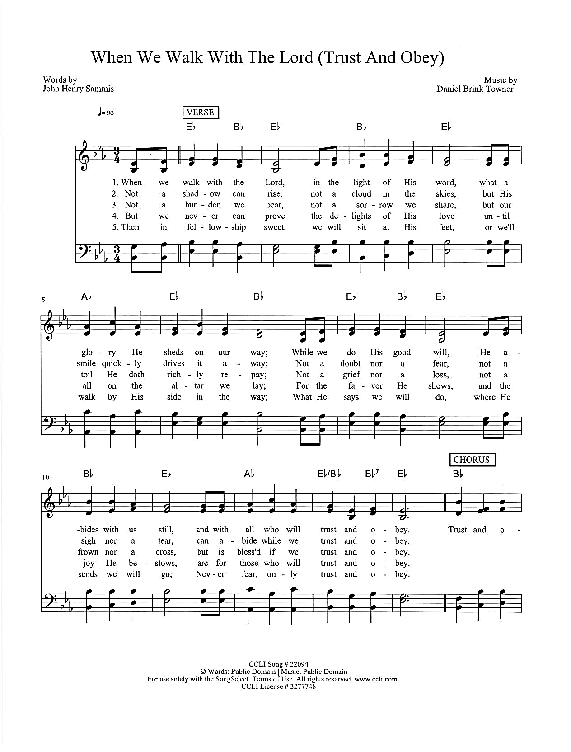

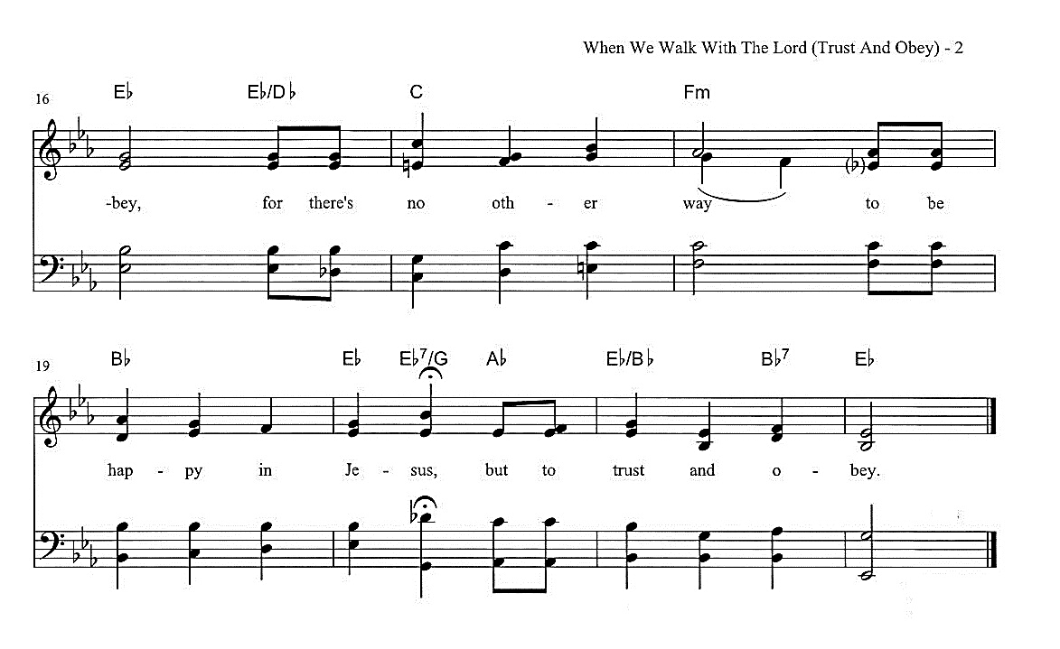



Blessing after Communion

Now may the body and blood of our Lord, Jesus Christ, strengthen you and keep you in God’s grace. **Amen.**

Prayer after Communion

Living One,

in this feast you have made yourself known to us.

Send us now to tell of your wonders,

sing of your glory,

and proclaim your risen life

to a wounded and weary world.

**Amen.**

**The Sending**

Why does our church exist? What is our purpose?

**We go out to transform lives through Jesus Christ.**

Purpose Sightings

MILESTONES! “Softly and Tenderly Jesus is Calling” vs. 1

*It's time for sharing milestones - a time where we join together as a community to share the big, small, good, and hard milestones in our life.*

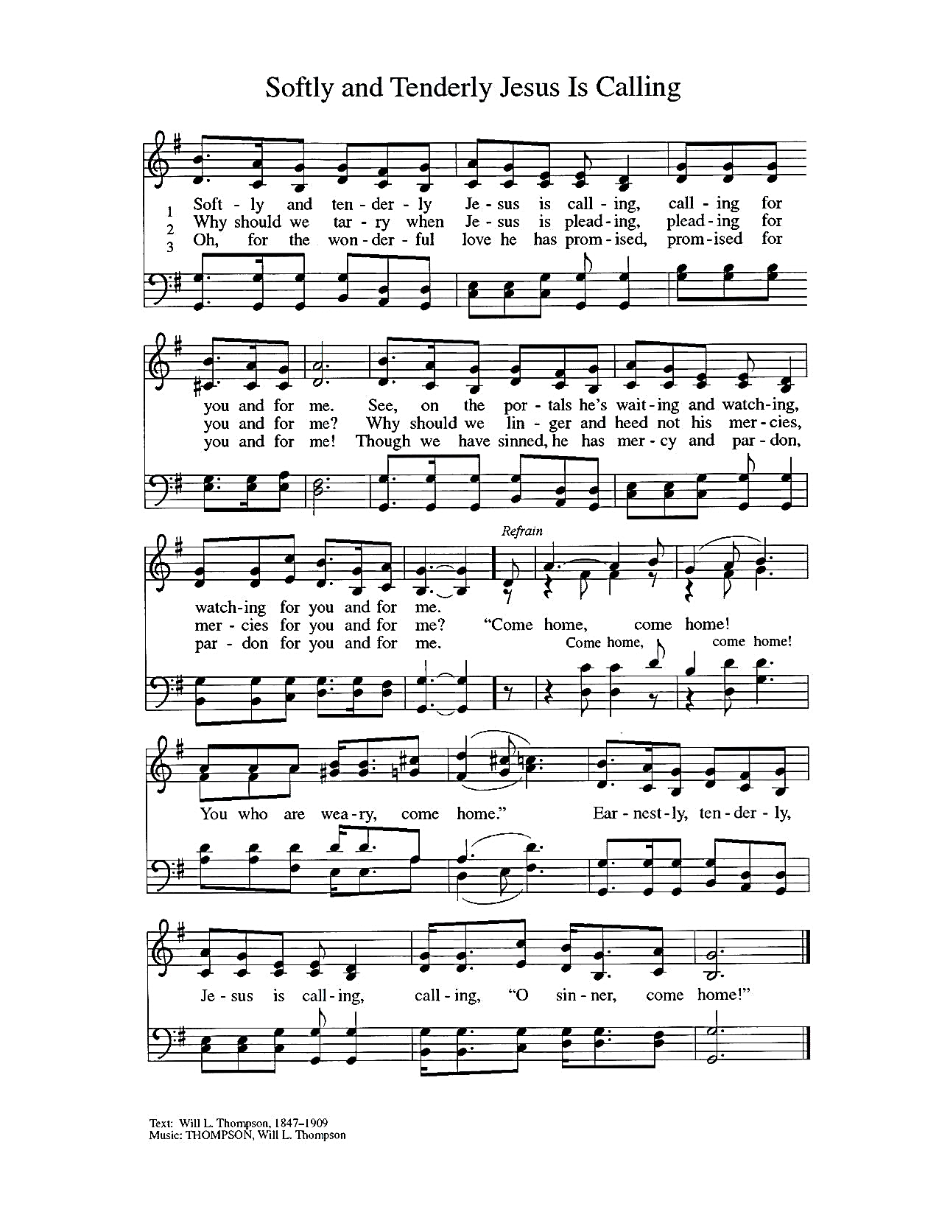Blessing

(Leader): *Receive these words of blessing from God found in Isaiah 41:10*

*So do not fear, for I am with you.*

*Do not be dismayed for I am your God.*

*I will strengthen you and help you,*

*I will uphold you with my righteous right hand.* **Amen.**

Sending Song: “Go in Peace”

*(Invite children of all ages to come forward and play percussion during the closing song)*

[This Photo](https://www.flickr.com/photos/oxfordshire_church_photos/413448324) by Unknown Author is licensed under [CC BY](https://creativecommons.org/licenses/by/3.0/)

[This Photo](https://www.flickr.com/photos/oxfordshire_church_photos/413448324) by Unknown Author is licensed under [CC BY](https://creativecommons.org/licenses/by/3.0/)



Go in peace, serve the Lord.. **Thanks be to God.**

Music to Send You Out

*From Sundays and Seasons.com. Copyright 2005 Augsburg Fortress. All rights reserved. Reprinted by permission under Augsburg Fortress Liturgies Annual License #SAS023086**CCLI License # 3277748*A picture containing text
*OneLicense.net license #A-726070*