14th Sunday After Pentecost
September 3, 2023

www.riverofhopehutchinson.org
Worship on Facebook Premiere, Sundays at 10:30am
Gathering
Prelude
Opening Song – “Sing Your Praise to the Lord”
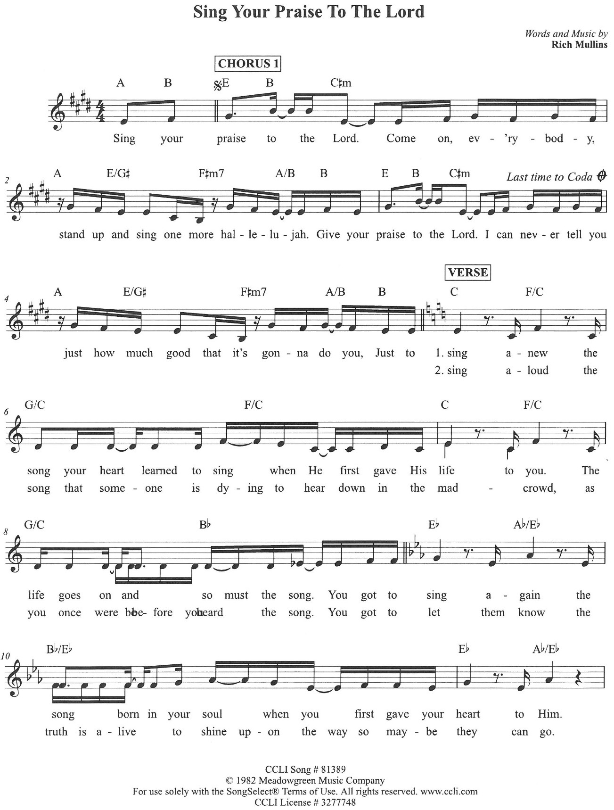
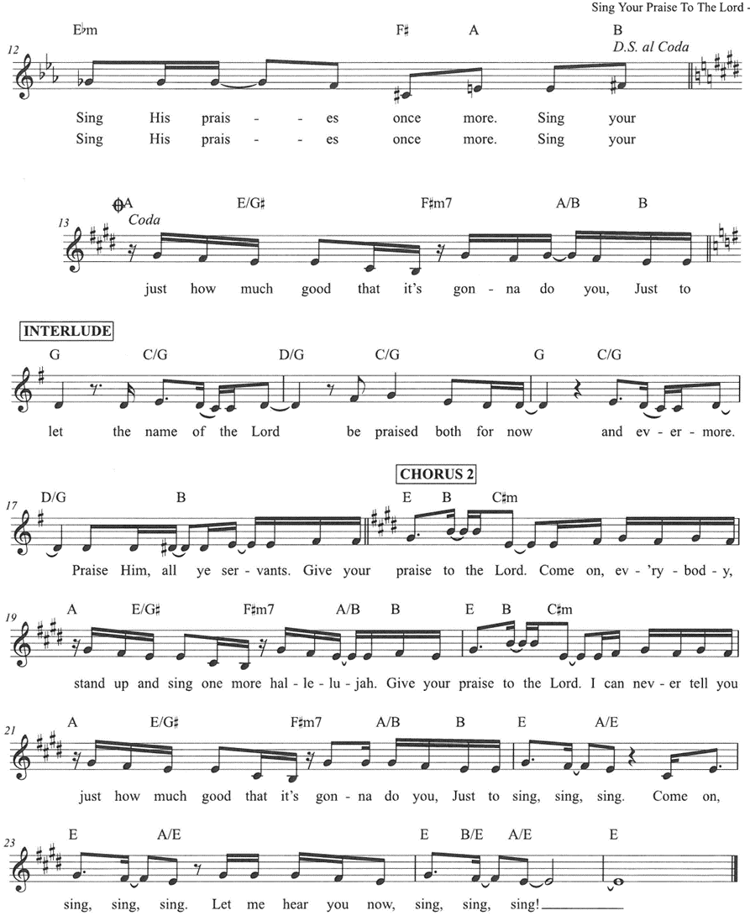

Welcome * Welcome Pads * Post it Notes *
This Photo by Unknown Author is licensed under CC BY
Wherever you are on your journey of faith, we believe God meets you right where you are, and you are welcome here.

Greeting
The grace of our Lord Jesus Christ, the love of God, and the community of the Holy Spirit is with you all. And also with you.

PRAYER OF THE DAY
(Leader): Let us pray,
O God, we thank you for your Son, who chose the path of suffering for the sake of the world. Humble us by his example, point us to the path of obedience, and give us strength to follow your commands, through Jesus Christ, our Savior and Lord. Amen.

Greet Someone New
Music to Bring Us Back Together: “Sing Your Praise to the Lord” (interlude / Chorus 2)

Children’s Time

The Story
(Reader): Our story and God’s story continues today with a reading from Matthew 16: 21-28.

(Reader): From that time on, [after Peter confessed that Jesus was the Messiah,] Jesus began to show his disciples that he must go to Jerusalem and undergo great suffering at the hands of the elders and chief priests and scribes, and be killed, and on the third day be raised. And Peter took him aside and began to rebuke him, saying,

(Side 1): “God forbid it, Lord! This must never happen to you.”

(Reader): But he turned and said to Peter,

(Side 2): “Get behind me, Satan! You are a stumbling block to me; for you are setting your mind not on divine things but on human things.”
(Reader): Then Jesus told his disciples,

(ALL): “If any want to become my followers, let them deny themselves and take up their cross and follow me.

(Reader): For those who want to save their life will lose it, and those who lose their life for my sake will find it. For what will it profit them if they gain the whole world but forfeit their life? Or what will they give in return for their life?
For the Son of Man is to come with his angels in the glory of his Father, and then he will repay everyone for what has been done. Truly I tell you, there are some standing here who will not taste death before they see the Son of Man coming in his kingdom.”

(Reader): Stay tuned for the continuing saga that is our story and God’s story.
(ALL): Thanks be to God.

Sermon – Pastor Hans Peterson

Song of the Day – “Sometimes By Step”

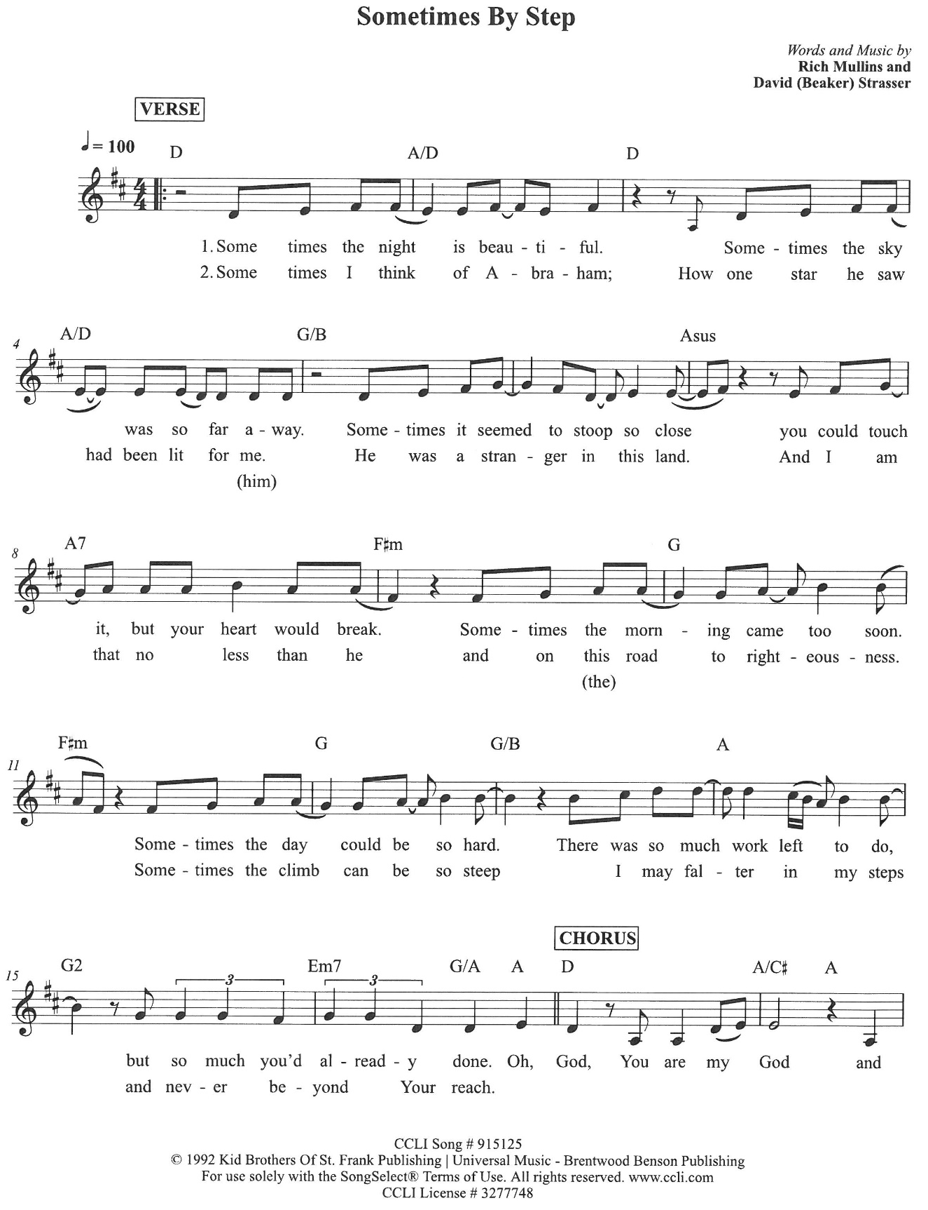

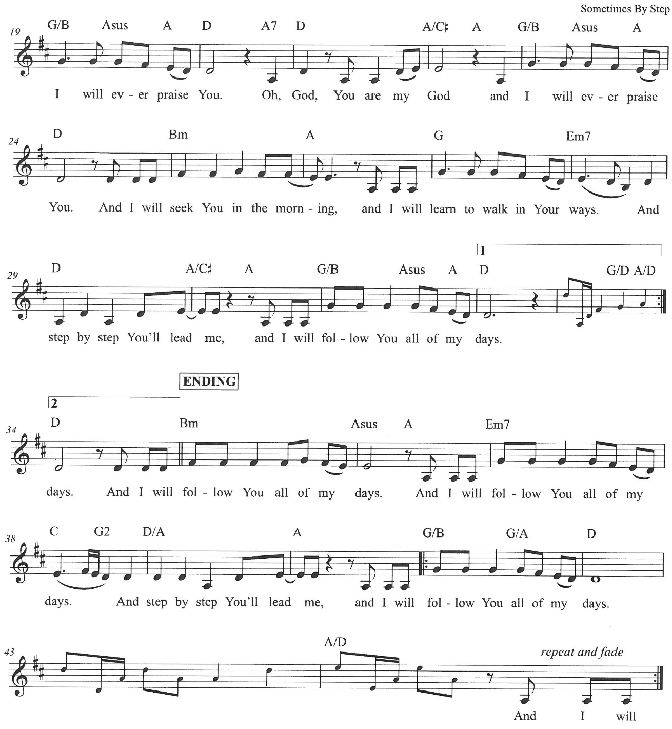

Prayers for the World
Together we pray for the church, the world, and all who are in need. Each petition will close with the words: God, who is mercy:
Congregational response: Hear our Prayer

Offering

Worship Leader: Thank you for your continued generosity and for all the ways you support God’s ministry here at River of Hope. You can contact the church office and sign up for simply giving or give online or drop a check off at the church office. The watering can this month is for “Habitat for Humanity”

Offering Song – “The Wonderful Cross”

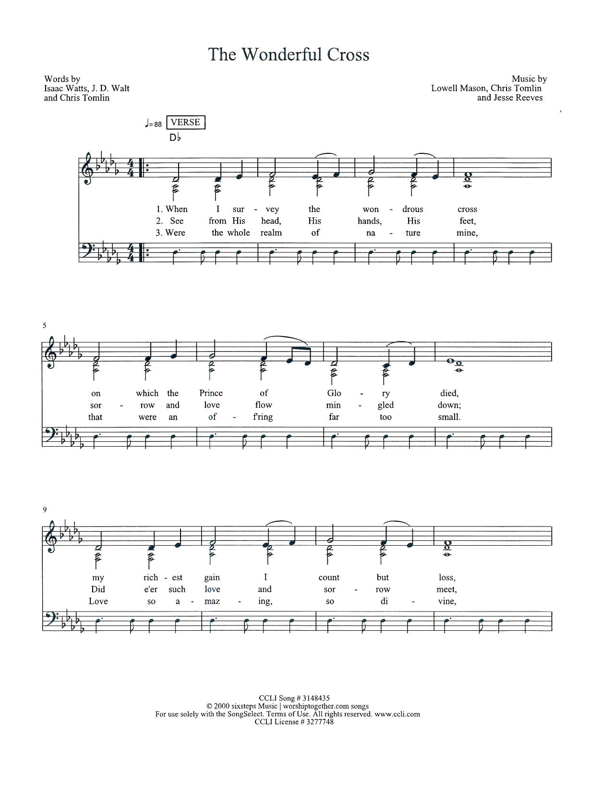
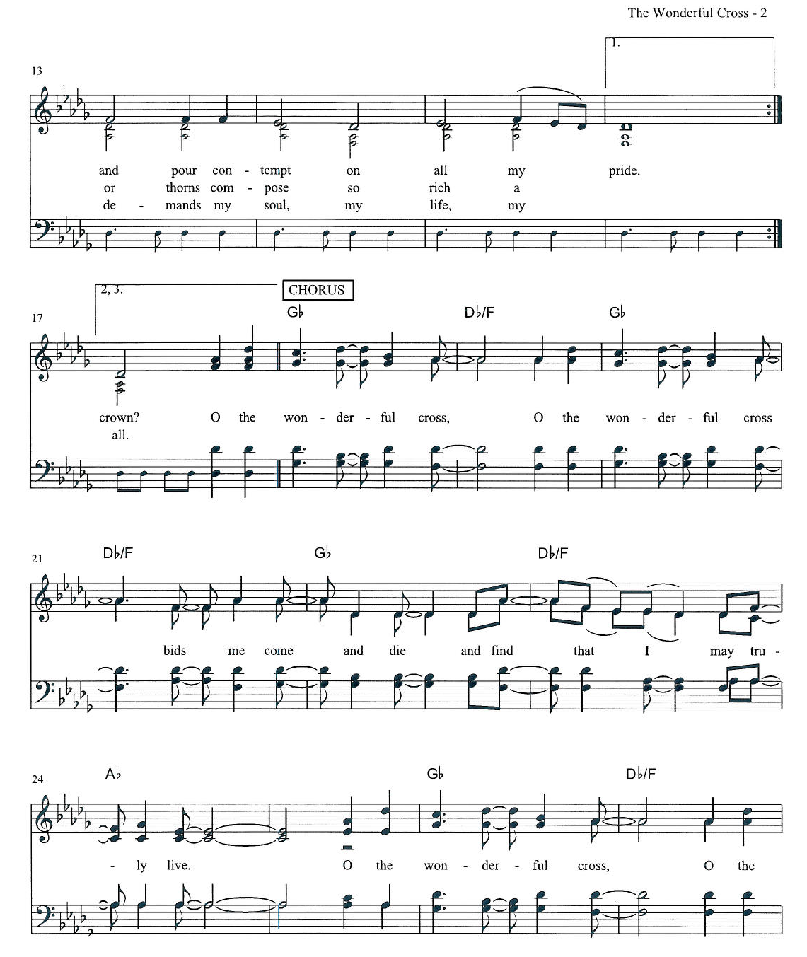

The Feast
Setting the Table the children lead us as we sing together:
O Come Lord Jesus be our Guest and let these gifts to us be blest. All praise to God who is our bread, may all the world be clothed and fed.

Thanksgiving at the Table

The Lord is with you
And also with you
Lift up your hearts!
We lift them to the Lord.
Let us give thanks to the Lord our God.
It is right to give God thanks and praise.

As we gather in this place, we remember, that in the night when Jesus was betrayed by his best friends, he took bread. He blessed it and broke it and gave it to these same friends saying, “Take and eat. This is my body given for you. Do this for the remembrance of me.”

After supper he took the cup, blessed it and gave it for all to drink saying, “This is the new covenant, the new promise, for the forgiveness of sins. Do this for the remembrance of me.” Lord, remember us in your kingdom and teach us to pray

Our Father, who art in heaven, hallowed be thy name,
thy kingdom come,
thy will be done,
on earth as it is in heaven.
Give us this day our daily bread. Forgive us our trespasses
as we forgive those
who trespass against us.
Lead us not into temptation
but deliver us from evil.
For thine is the kingdom,
and the power,
and the glory
forever and forever. Amen.

This is Christ's table. It's a table of love and welcome. It's a table of fellowship with the poor and communion with the earth.
So, come, those of you with great faith and those of you who wish you had more. Come, those of you who have tried to follow Jesus and those of you who have failed. Come, those of you who depend on this meal for your lives, and those of you for whom it is a strange thing.
These are the gifts of God for the people of God.

Communion Song: “Take Up Your Cross” the Savior Said; and “Jesus, Keep Me Near the Cross”

Blessing after Communion
Now may the body and blood of our Lord, Jesus Christ, strengthen you and keep you in God’s grace. Amen.

Prayer after Communion
God of the abundant table,
you have refreshed our hearts in this meal
with bread for the journey.
Give us your grace on the road
that we might serve our neighbors with joy;
for the sake of Jesus Christ, our Lord.
Amen.

The Sending

Why does our church exist? What is our purpose?
We go out to transform lives through Jesus Christ.

Purpose Sightings:

MILESTONES! Sing “In the Cross of Christ I Glory” Vs. 1
It's time for sharing milestones - a time where we join together as a community to share the big, small, good, and hard milestones in our life.

“Who’s child are you question”

Sung Benediction – Hans and Jim

Sending Song: “Awesome God”

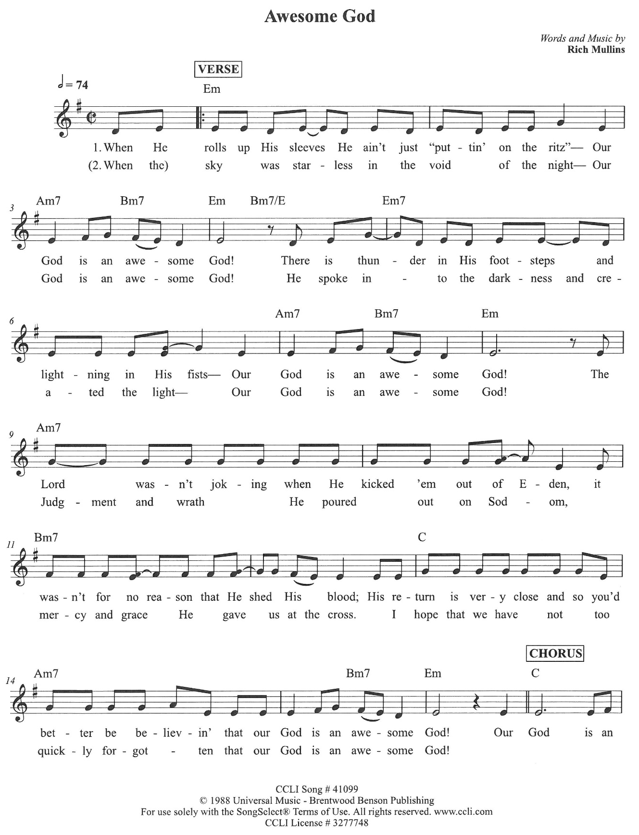

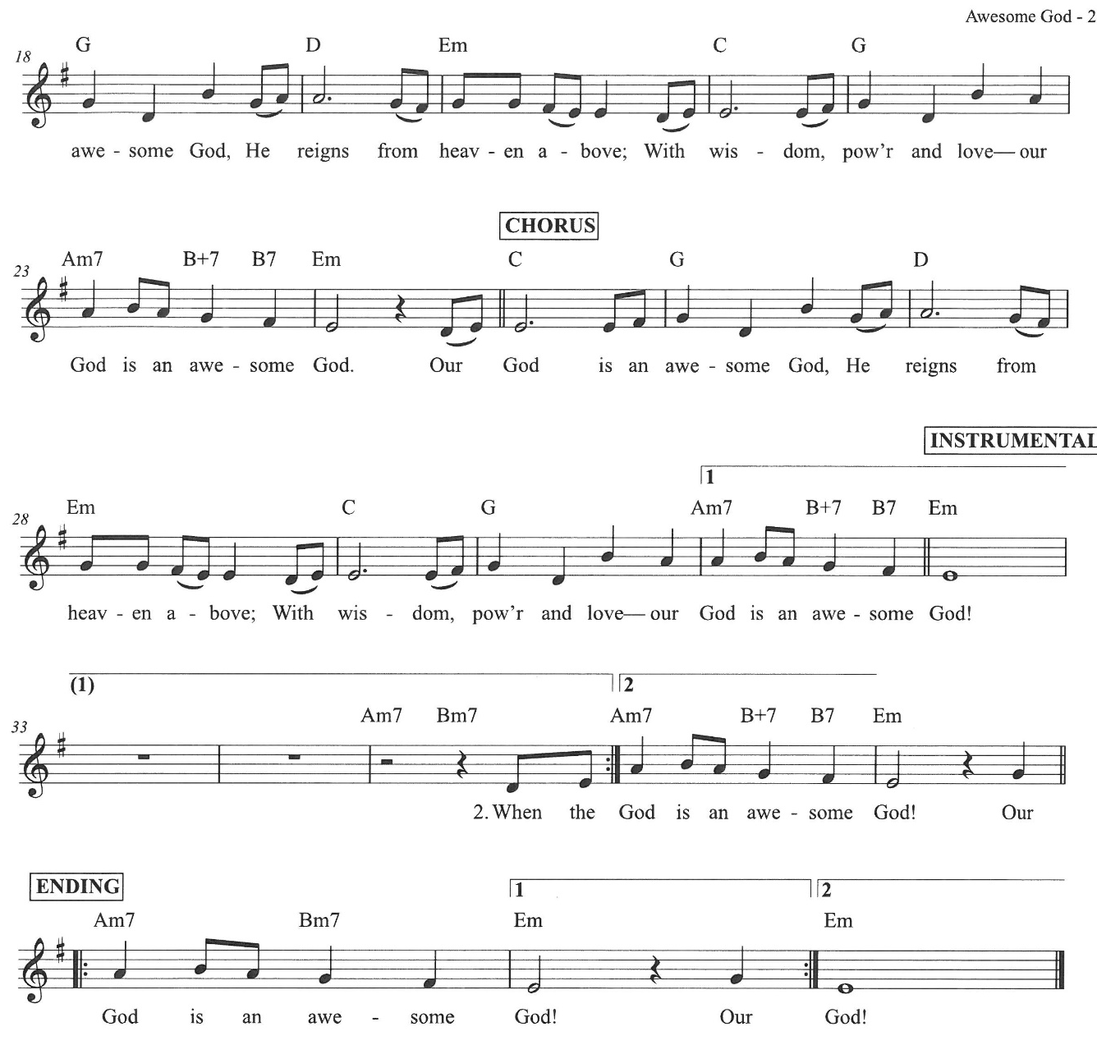

Go in peace – serve the Lord! Thanks be to God
Music to Send You Out
From Sundays and Seasons.com. Copyright 2005 Augsburg Fortress. All rights reserved. Reprinted by permission under Augsburg Fortress Liturgies Annual License #SAS023086 CCLI License # 3277748 OneLicense.net license #A-726070

