12th Sunday After Pentecost
August 20, 2023

www.riverofhopehutchinson.org
Worship on Facebook Premiere, Sundays at 10:30am
Gathering
Prelude
Welcome and invite people to sing opening song
Opening Songs – “Here I am to Worship”, “Vagabonds”
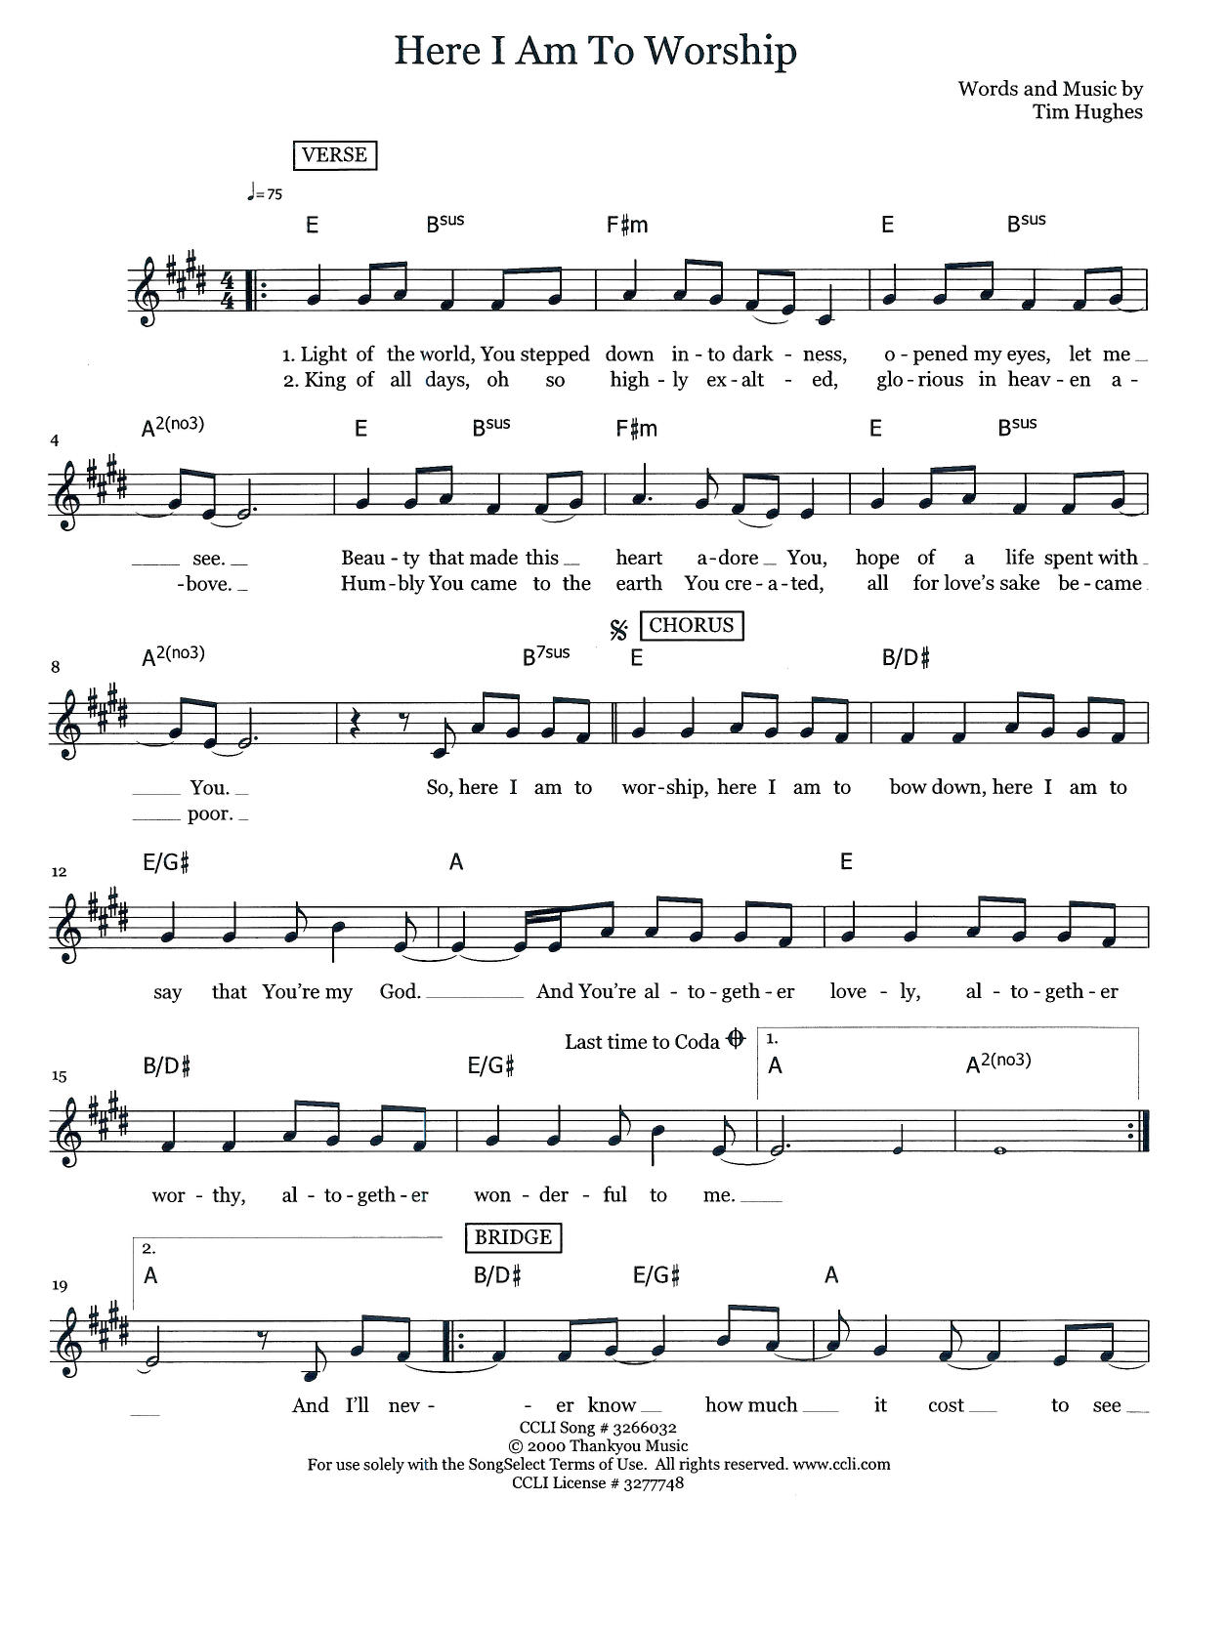

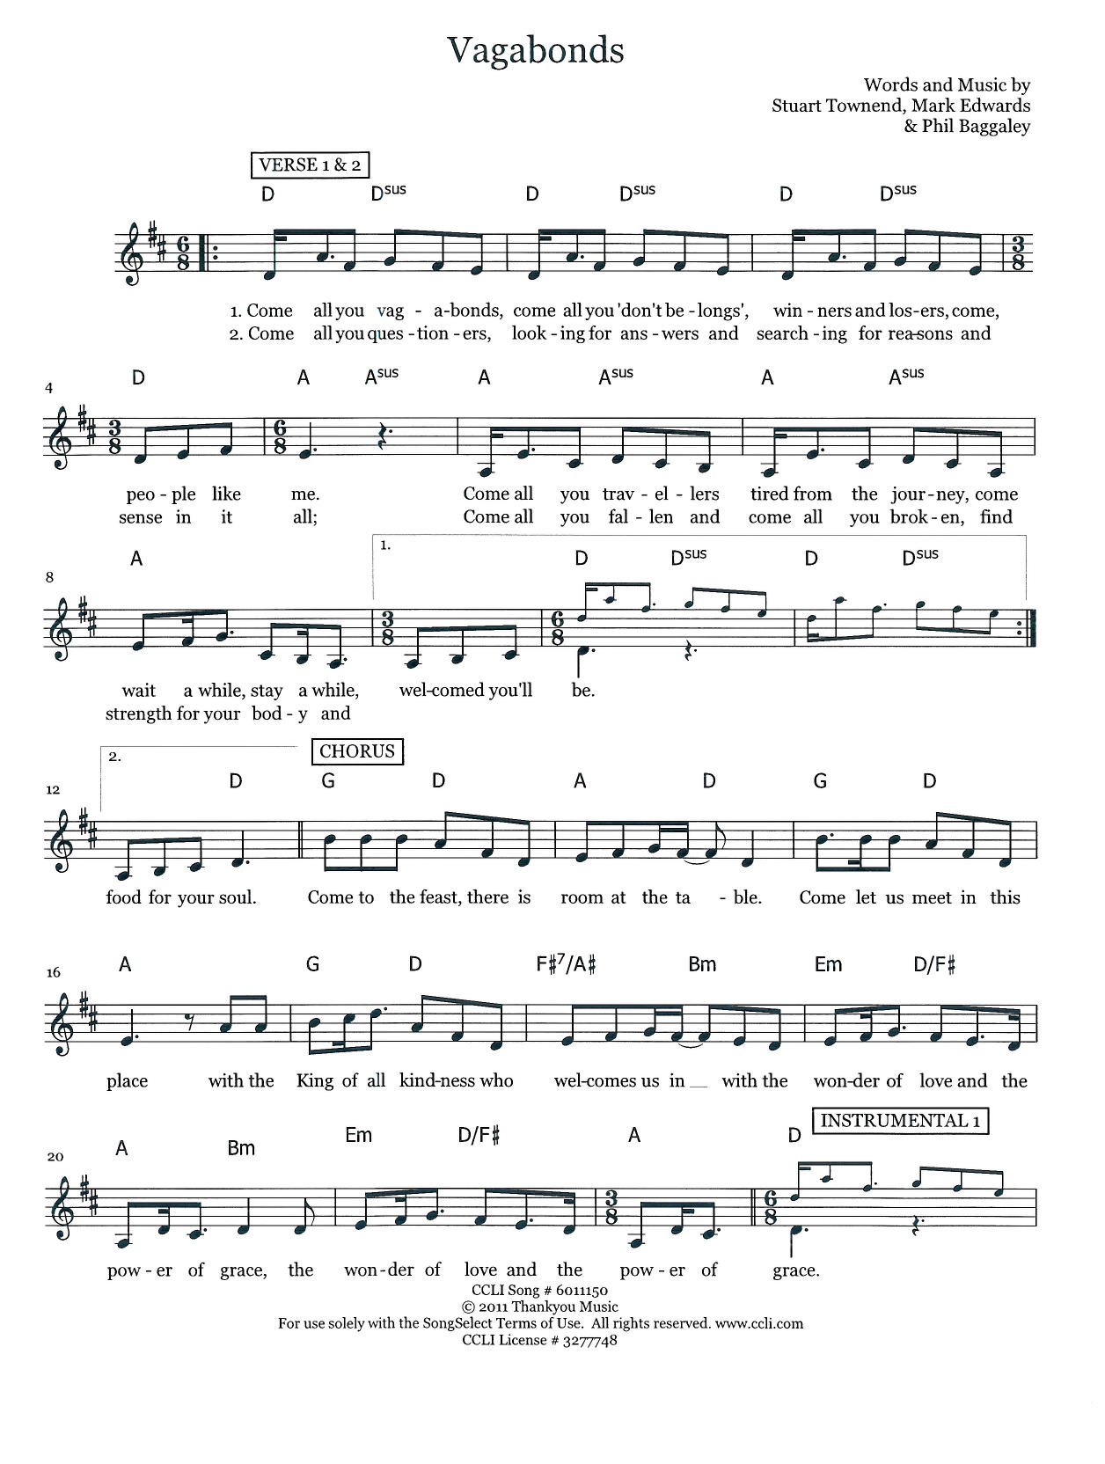
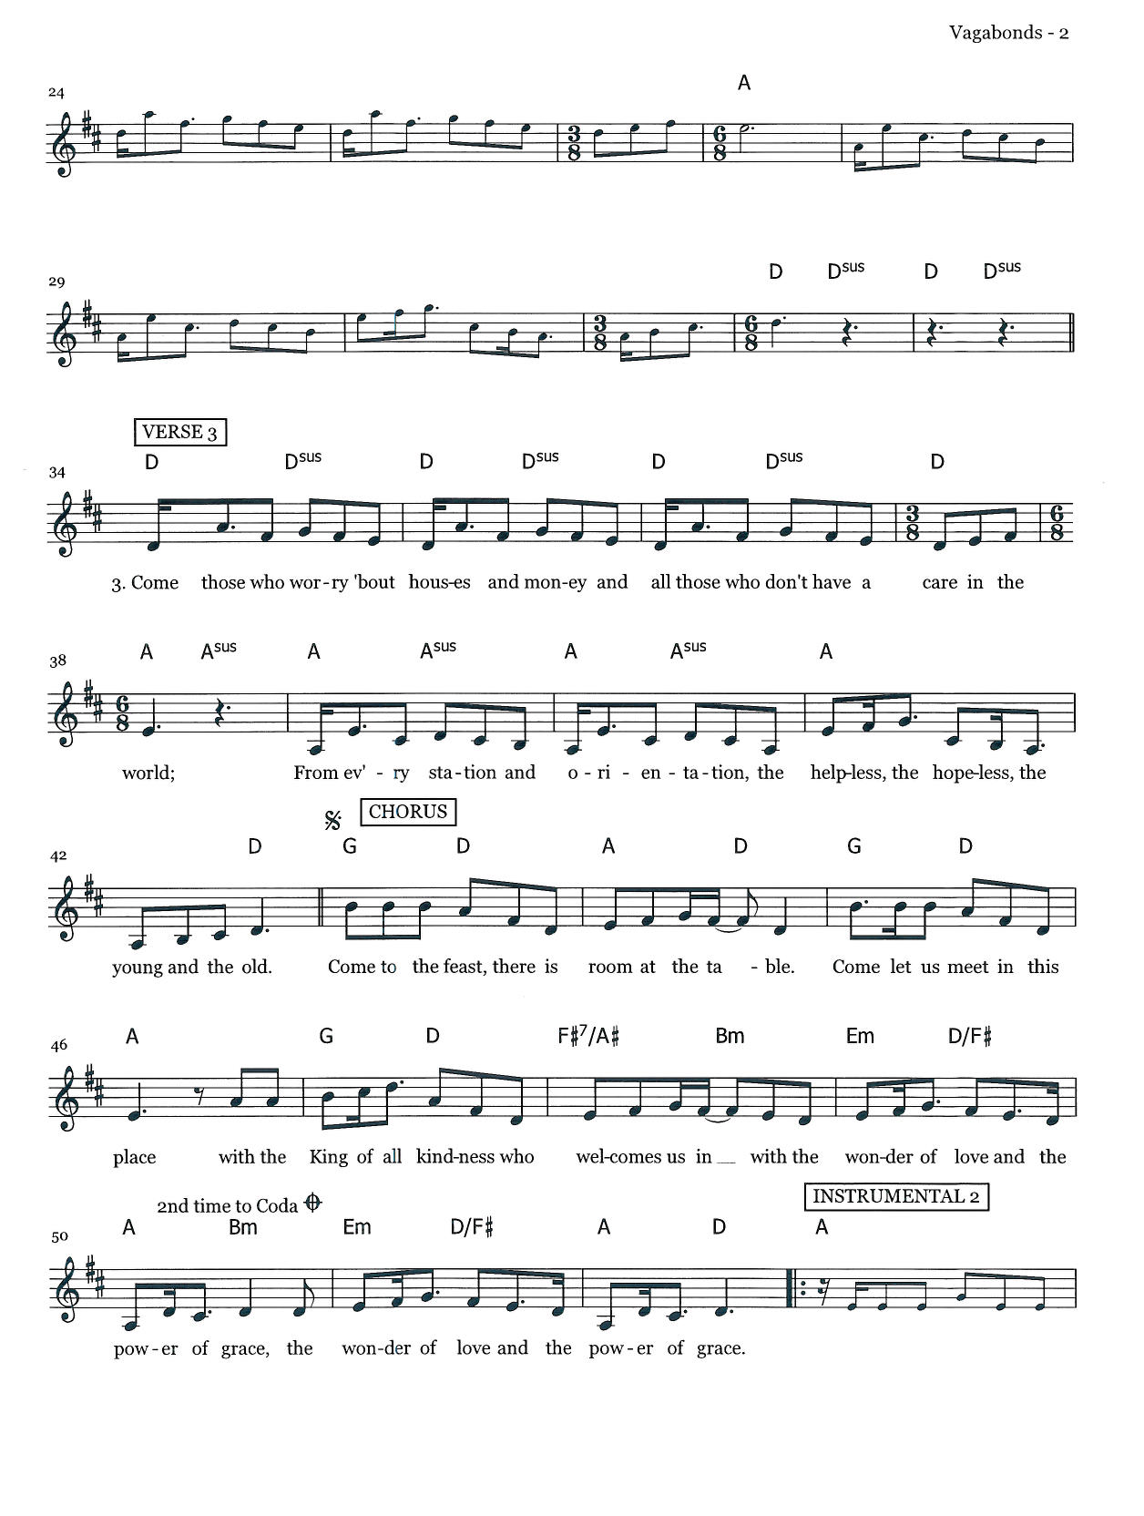
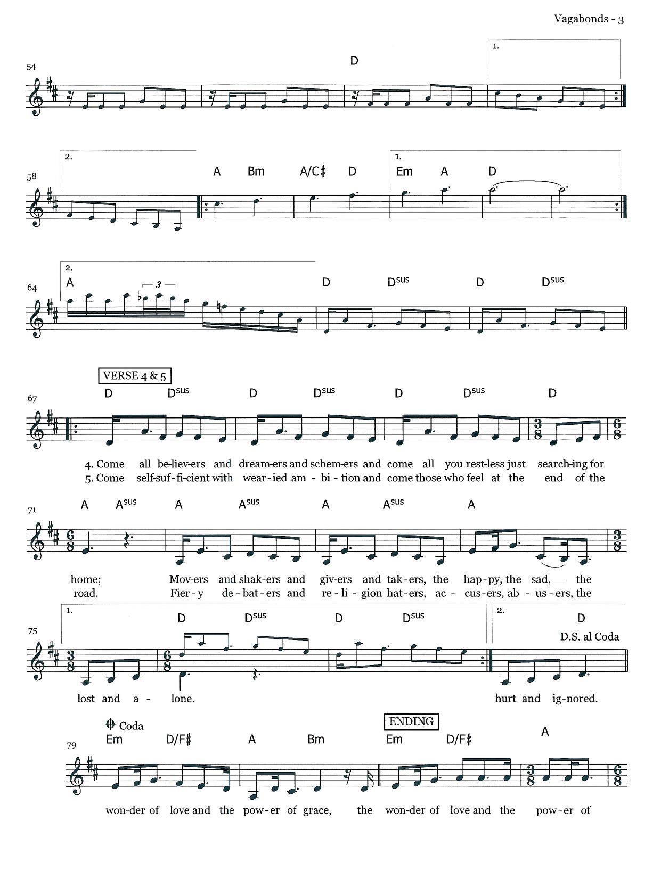

Welcome * Welcome Pads * Post it Notes *
This Photo by Unknown Author is licensed under CC BY
Wherever you are on your journey of faith, we believe God meets you right where you are, and you are welcome here.

Greeting
The grace of our Lord Jesus Christ, the love of God, and the community of the Holy Spirit is with you all. And also with you.

Confession and Forgiveness
Blessed be the holy Trinity,☩ one God,
who greets us in this and every season,
whose word never fails,
whose promise is sure.

Amen.

Let us confess our sin in the presence of God
and of our neighbors.
Merciful God,

we confess that we have sinned.
We have hurt our community.
We have squandered your blessings.
We have hoarded your bounty.
In the name of Jesus,
forgive us and grant us your mercy.

Silence is kept for reflection.
Righteous God,
we confess that we have sinned.
We have failed to be honest.
We have lacked the courage to speak.
We have spoken falsely.
In the name of Jesus,
forgive us and grant us your mercy.

God is a cup of cold water when we thirst.
God offers boundless grace when we fail.
Claim the gift of God’s mercy:
you are freed and forgiven
in the name of ☩ Jesus Christ.

Amen.

PRAYER OF THE DAY
(Reader): Let us pray,
God of all peoples, your arms reach out to embrace all those who call upon you. Teach us as disciples of your Son to love the world with compassion and constancy, that your name may be known throughout the earth, through Jesus Christ, our Savior and Lord.
Amen.

Greet Someone New
Music to Bring Us Back Together: Verse 4-end of “Vagabonds”

Children’s Time

The Story
(Reader): Our story and God’s story continues today with a reading from Matthew 15: 10-28.
(Reader): Jesus called the crowd to him and said to them,

(Side 1): “Listen and understand: it is not what goes into the mouth that defiles a person, but it is what comes out of the mouth that defiles.”

(Reader): Then the disciples approached and said to him,

(Side 2): “Do you know that the Pharisees took offense when they heard what you said?”

(Reader): He answered, “Every plant that my heavenly Father has not planted will be uprooted. Let them alone; they are blind guides of the blind. And if one blind person guides another, both will fall into a pit.” But Peter said to him, “Explain this parable to us.” Then he said, “Are you also still without understanding? Do you not see that whatever goes into the mouth enters the stomach, and goes out into the sewer? But what comes out of the mouth proceeds from the heart, and this is what defiles. For out of the heart come evil intentions, murder, adultery, fornication, theft, false witness, slander. These are what defile a person, but to eat with unwashed hands does not defile.”
Jesus left that place and went away to the district of Tyre and Sidon. Just then a Canaanite woman from that region came out and started shouting,

(Side 1): “Have mercy on me, Lord, Son of David; my daughter is tormented by a demon.”

(Reader): But he did not answer her at all. And his disciples came and urged him, saying,

(Side 2): “Send her away, for she keeps shouting after us.”

(Reader): He answered, “I was sent only to the lost sheep of the house of Israel.” But she came and knelt before him, saying, “Lord, help me.” He answered, “It is not fair to take the children’s food and throw it to the dogs.” She said, “Yes, Lord, yet even the dogs eat the crumbs that fall from their masters’ table.” Then Jesus answered her,

(ALL): “Woman, great is your faith! Let it be done for you as you wish.”

(Reader): And her daughter was healed instantly.

(Reader): Stay tuned for the continuing saga that is our story and God’s story.

(ALL): Thanks be to God.

Sermon – Pastor Linda Pedersen

Song of the Day – “Great is Thy Faithfulness”

Prayers for the World
Together we pray for the church, the world, and all who are in need. Each petition will close with the words: God, who is mercy:
Congregational response “Hear our Prayer”

Offering

Worship Leader: Thank you for your continued generosity and for all the ways you support God’s ministry here at River of Hope. You can contact the church office and sign up for simply giving or give online or drop a check off at the church office. The watering can this month is for Common Cup.

Offering Song – “I Danced in the Morning”

The Feast
Setting the Table the children lead us as we speak together:
Come Lord Jesus be our Guest and let these gifts to us be blest. All praise to God who is our bread, may all the world be clothed and fed.

Thanksgiving at the Table

The Lord is with you
And also with you
Lift up your hearts!
We lift them to the Lord.
Let us give thanks to the Lord our God.
It is right to give God thanks and praise.

As we gather in this place, we remember, that in the night when Jesus was betrayed by his best friends, he took bread. He blessed it and broke it and gave it to these same friends saying, “Take and eat. This is my body given for you. Do this for the remembrance of me.”

After supper he took the cup, blessed it and gave it for all to drink saying, “This is the new covenant, the new promise, for the forgiveness of sins. Do this for the remembrance of me.” Lord, remember us in your kingdom and teach us to pray
Our Father, who art in heaven, hallowed be thy name,
thy kingdom come,
thy will be done,
on earth as it is in heaven.
Give us this day our daily bread. Forgive us our trespasses
as we forgive those
who trespass against us.
Lead us not into temptation
but deliver us from evil.
For thine is the kingdom,
and the power,
and the glory
forever and forever. Amen.

This is Christ's table. It's a table of love and welcome. It's a table of fellowship with the poor and communion with the earth.
So, come, those of you with great faith and those of you who wish you had more. Come, those of you who have tried to follow Jesus and those of you who have failed. Come, those of you who depend on this meal for your lives, and those of you for whom it is a strange thing.
These are the gifts of God for the people of God.

Communion Song: “One Bread, One Body”; “Be Unto Your Name”

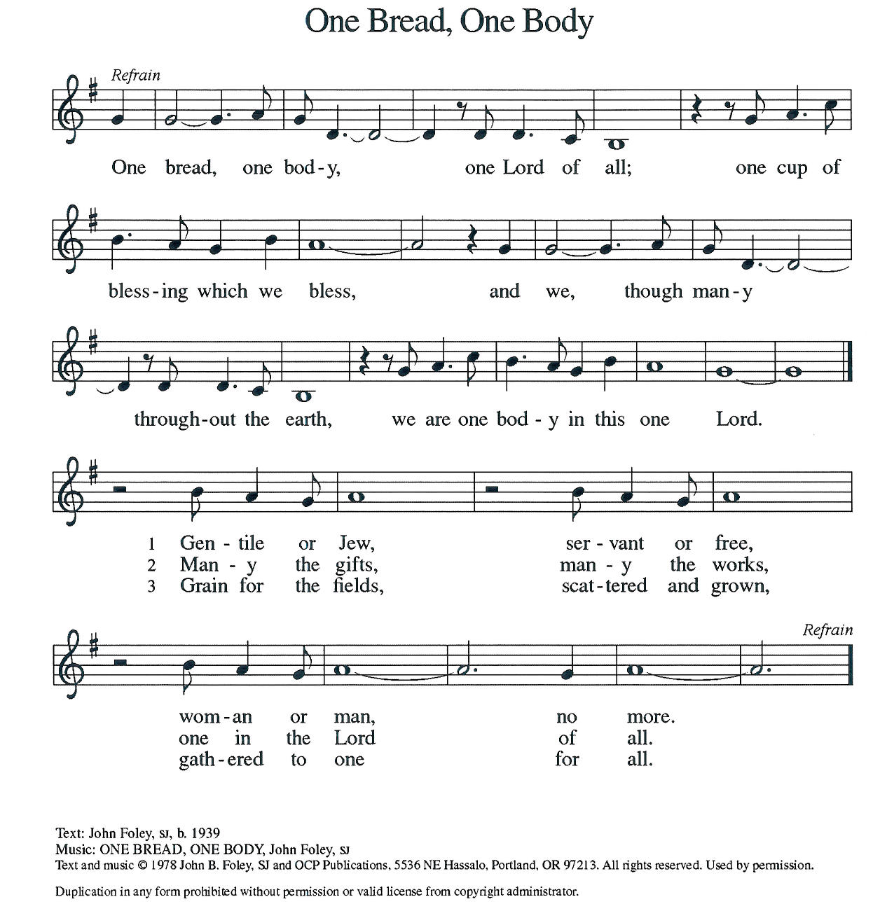

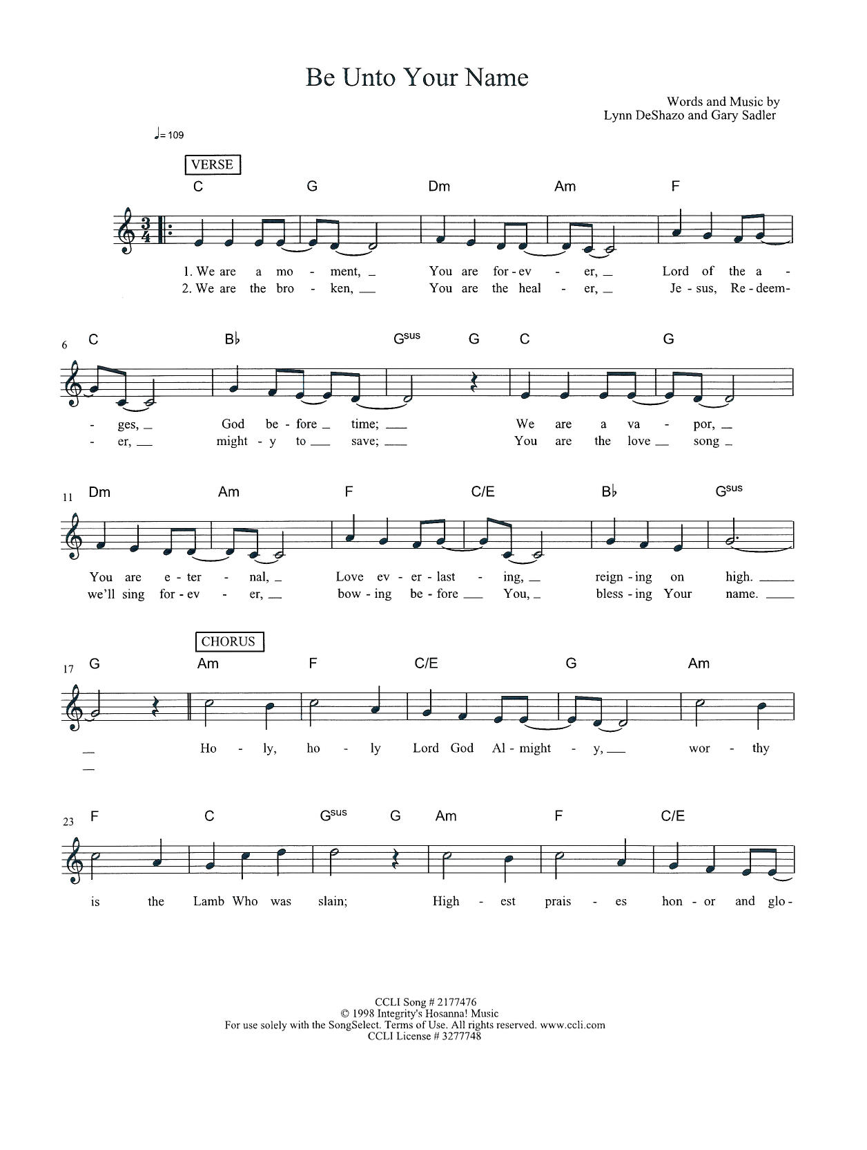

LINDA: Blessing after Communion
Now may the body and blood of our Lord, Jesus Christ, strengthen you and keep you in God’s grace. Amen.

LINDA: Prayer after Communion
God of the abundant table,
you have refreshed our hearts in this meal
with bread for the journey.
Give us your grace on the road
that we might serve our neighbors with joy;
for the sake of Jesus Christ, our Lord.
Amen.

The Sending

LINDA: Why does our church exist? What is our purpose?
We go out to transform lives through Jesus Christ.

LINDA: Purpose Sightings:

MILESTONES! Sing “Rock of Ages, Cleft for Me” vs. 1
It's time for sharing milestones - a time where we join together as a community to share the big, small, good, and hard milestones in our life.

LINDA: Closing Benediction
Now may the Lord bless you and keep you.
The Lord’s face shine on you with grace and mercy.
The Lord look upon you with favor and + give you peace.

Sending Song: “All the People Said Amen”

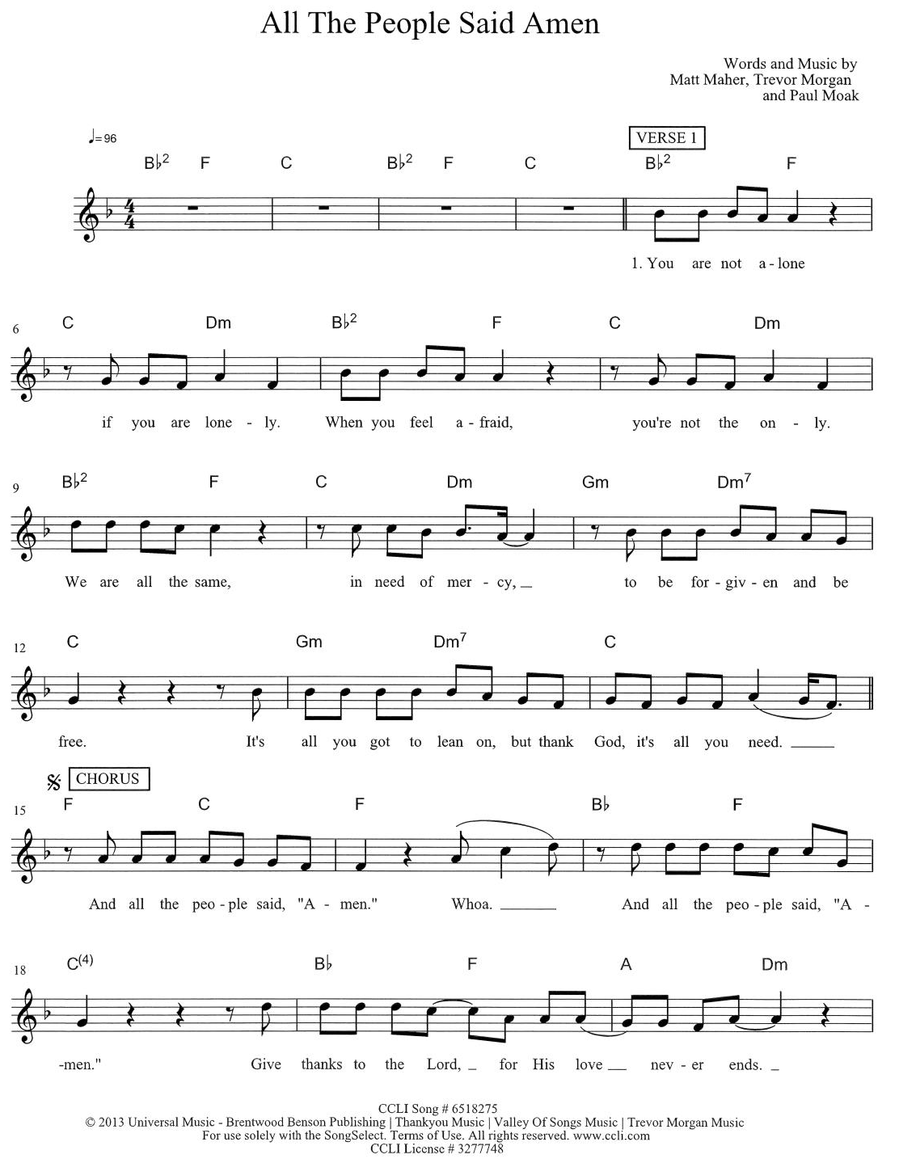

Go in peace – serve the Lord! Thanks be to God
Music to Send You Out
From Sundays and Seasons.com. Copyright 2005 Augsburg Fortress. All rights reserved. Reprinted by permission under Augsburg Fortress Liturgies Annual License #SAS023086 CCLI License # 3277748 OneLicense.net license #A-726070

