3rd Sunday of Easter
May 1, 2022
This Photo by Unknown Author is licensed under CC BY-SA
This Photo by Unknown Author is licensed under CC BY
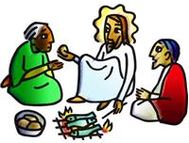

www.riverofhopehutchinson.org
Worship on Facebook Premiere, Sundays at 10:30am

Gathering

Music to Prepare Us For Worship

GATHERING SONG – “Shout to the North”
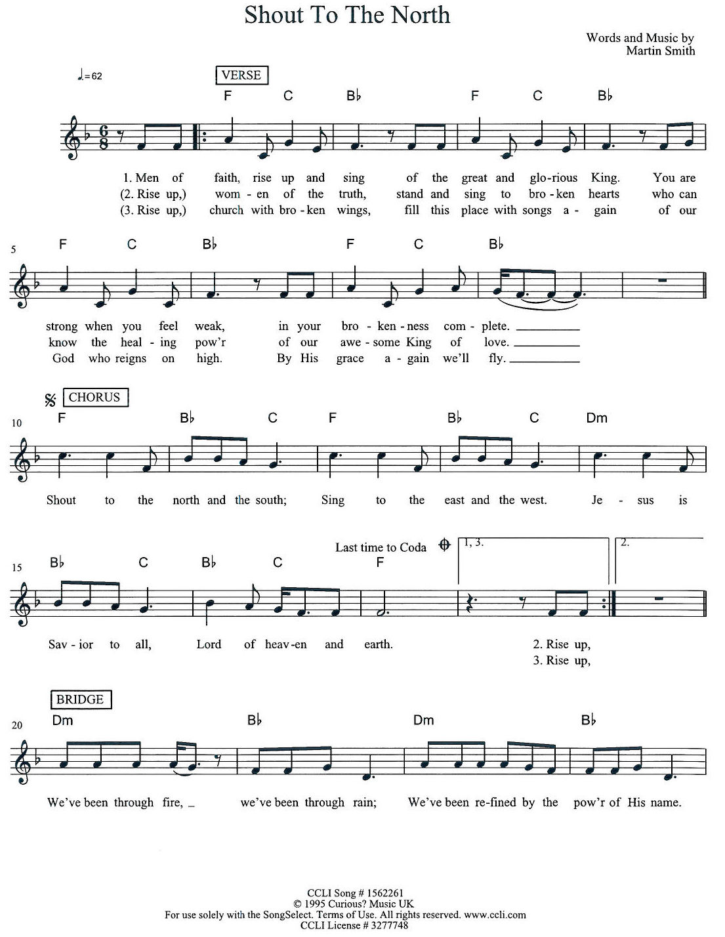

Welcome
This Photo by Unknown Author is licensed under CC BY
Wherever you are on your journey of faith, we believe God meets you right where you are, and you are welcome here.

CONFESSION

Let us confess that God is God and we are not.
If we say we have no sin, we deceive ourselves, and the truth is not in us. But if we speak the truth of who we are, we are reminded once again of how passionately God loves us.

Silence for confession

God of mercy,
We confess that we don’t have everything figured out. We confess that we are not holy like you are holy. We confess that we try to not need you. We confess that we try to not need each other. Forgive us for the ways in which we do not act like your beloved children and bring us again to resurrection.

Hear this Good News:
God who is gracious and merciful, slow to anger and abounding in steadfast love – loves you as you are. As a called and ordained minister of the church of Christ and by his authority, I declare to you – you are forgiven! Your sin is as far removed as the east is from the west. You are not defined by your mistakes. Your story is God’s story and so you are transformed and made new. You, each of you, a beloved Child of God. Amen! Alleluia!

Greet Someone New
Music to Bring Us Back Together

SONG OF PRAISE “Gloria”

Children’s Time

PRAYER OF THE DAY
Let us pray.
Eternal and all-merciful God, with all the angels and all the saints we laud your majesty and might. By the resurrection of your Son, show yourself to us and inspire us to follow Jesus Christ, our Savior and Lord, who lives and reigns with you and the Holy Spirit, one God, now and forever.
Amen.
The Word

(Reader): Our first reading today is Psalm 30, which we will read responsively.

(Reader): I will exalt you, O Lord, because you have lifted me up
and have not let my enemies triumph over me.
(ALL): O Lord my God, I cried out to you,
and you restored me to health.
(Reader): You brought me up, O Lord, from the dead;
you restored my life as I was going down to the grave.
(ALL): Sing praise to the Lord, all you faithful;
give thanks in holy remembrance.
(Reader): God’s wrath is short; God’s favor lasts a lifetime.
Weeping spends the night, but joy comes in the morning.
(ALL): While I felt secure, I said,
“I shall never be disturbed.
(Reader): You, Lord, with your favor, made me as strong as the mountains.
Then you hid your face, and I was filled with fear.
(ALL): I cried to you, O Lord;
I pleaded with my Lord, saying,
(Reader): “What profit is there in my blood, if I go down to the pit?
Will the dust praise you or declare your faithfulness?
(ALL): Hear, O Lord, and have mercy upon me;
O Lord, be my helper.”
(Reader): You have turned my wailing into dancing;
you have put off my sackcloth and clothed me with joy.
(ALL): Therefore my heart sings to you without ceasing;
O Lord my God, I will give you thanks forever.

(Reader): Our story and God’s story continues today with a reading from the Gospel of John, Chapter 21, verses 1-19.

(Reader): After [he appeared to his followers in Jerusalem,] Jesus showed himself again to the disciples by the Sea of Tiberias; and he showed himself in this way. Gathered there together were Simon Peter, Thomas called the Twin, Nathanael of Cana in Galilee, the sons of Zebedee, and two others of his disciples. Simon Peter said to them,

(Side 1): “I am going fishing.”

(Reader): They said to him,

(Side 2): “We will go with you.”

(Reader): They went out and got into the boat, but that night they caught nothing. Just after daybreak, Jesus stood on the beach; but the disciples did not know that it was Jesus. Jesus said to them,

(Side 1): “Children, you have no fish, have you?”

(Reader): They answered him,

(Side 2): “No.”

(Reader): He said to them,

(Side 1): “Cast the net to the right side of the boat, and you will find some.”

(Reader): So they cast it, and now they were not able to haul it in because there were so many fish. That disciple whom Jesus loved said to Peter,

(Side 2): “It is the Lord!”

(Reader): When Simon Peter heard that it was the Lord, he put on some clothes, for he was naked, and jumped into the sea. But the other disciples came in the boat, dragging the net full of fish, for they were not far from the land, only about a hundred yards off. When they had gone ashore, they saw a charcoal fire there, with fish on it, and bread. Jesus said to them,

(Side 1): “Bring some of the fish that you have just caught.”

(Reader): So Simon Peter went aboard and hauled the net ashore, full of large fish, a hundred fifty-three of them; and though there were so many, the net was not torn. Jesus said to them,

(Side 2): “Come and have breakfast.”

(Reader): Now none of the disciples dared to ask him, “Who are you?” because they knew it was the Lord. Jesus came and took the bread and gave it to them, and did the same with the fish. This was now the third time that Jesus appeared to the disciples after he was raised from the dead. When they had finished breakfast, Jesus said to Simon Peter,

(Side 1): “Simon son of John, do you love me more than these?”

(Reader): He said to him,

(Side 2): “Yes, Lord; you know that I love you.”

(Reader): Jesus said to him,

(Side 1): “Feed my lambs.”

(Reader): A second time he said to him,

(Side 2): “Simon son of John, do you love me?”

(Reader): He said to him,

(Side 1): “Yes, Lord; you know that I love you.”

(Reader): Jesus said to him, “Tend my sheep.” He said to him the third time,

(Side 2): “Simon son of John, do you love me?”

(Reader): Peter felt hurt because he said to him the third time, “Do you love me?” And he said to him,

(ALL): “Lord, you know everything; you know that I love you.”

(Reader): Jesus said to him, “Feed my sheep. Very truly, I tell you, when you were younger, you used to fasten your own belt and to go wherever you wished. But when you grow old, you will stretch out your hands, and someone else will fasten a belt around you and take you where you do not wish to go.” (He said this to indicate the kind of death by which he would glorify God.) After this he said to him, “Follow me.”

(Reader): Stay tuned for the continuing saga that is our story and God’s story.

(ALL): Thanks be to God.

SERMON - Pastor Hans Peterson

SONG OF THE DAY - “Dance With Me”

Blessing of New Hopefuls to River of Hope
Those new to River of Hope come to the center of the worship space, between the altar and the baptismal font. Those serving on the River Table and the Vision Table will come forward and bless the New Hopefuls.

Christian community sends us into the lives of other people. It is why River of Hope prays and then practices the No Longer Strangers prayer each week. We are certain that the powerful, wily ways of the Holy Spirit brought you into the community of River of Hope. And for this action and for you, we thank God. Dietrich Bonhoeffer, a Lutheran theologian, says this about community: “We must be ready to allow ourselves to be interrupted by God. God will be constantly crossing our paths and canceling our plans by sending us people with claims and petitions.”

Welcome to a life of interruption after interruption after interruption. It is the way of the cross. It is the way of Jesus.

Andy and Alissa Evenson, Genevieve (Ginny) Evenson, Mathilde (Hilde) Evenson
Katia Osman
Malena Kelm

Receive the sign of the cross on your shoulders that you may bear the gentle yoke
of Christ. +

Receive the sign of the cross on your eyes, that you may see the light of Christ, illumination for the world. +

Receive the sign of the cross on your feet, that you may walk in the way of Christ, inspired by God’s Holy Spirit. +

Receive the sign of the cross on your ears, that you may listen for Christ in your neighbor. +

Receive the sign of the cross on your hands, that you may do the work of Christ in your daily life. +

Receive the sign of the cross on your heart, that God may dwell there by faith. +

Welcome to River of Hope and the purpose we share: we go out to transform lives through Jesus Christ. We join with you in this walk of faith, no matter the twists and turns, and celebrate with you this life of following Jesus together. Thanks be to God!

PRAYERS OF THE PEOPLE
God, who is mercy
Hear our prayer.

OFFERING

OFFERING SONG “Let Us Talents and Tongues Employ”

The Feast

Setting the Table the children lead us as we pray together:
Song: “Many Will Come”

Invitation to the Meal
This is not my table or River of Hope’s table, but rather this is Christ’s table and all are welcome. If you hunger and thirst for grace and mercy that comes through Jesus Christ, then Christ has set this table just for you. Bring all that you are and all that you have to the table. You will be fed. You are forgiven. There is enough.

Let us pray, God of all good gifts who gives freely to us,
You offer us new beginnings and guide us on our journey. Lead us to your table, nourish us with this heavenly food, and prepare us to carry your love to a hungry world, in the name of Christ our light. Amen

Thanksgiving at the Table

The Lord is with you
And also with you
Lift up your hearts!
We lift them to the Lord.
Let us give thanks to the Lord our God.
It is right to give God thanks and praise.

As we gather in this place, we remember, that in the night when Jesus was betrayed by his best friends, he took bread. He blessed it and broke it and gave it to these same friends saying, “Take and eat. This is my body given for you. Do this for the remembrance of me.”

After supper he took the cup, blessed it and gave it for all to drink saying, “This is the new covenant, the new promise, for the forgiveness of sins. Do this for the remembrance of me.” Lord, remember us in your kingdom and teach us to pray:

The Lord’s Prayer

Our Father who art in heaven
hallowed be thy name,
thy kingdom come,
thy will be done,
on earth as it is in heaven.
Give us this day our daily bread.
Forgive us our trespasses
as we forgive those
who trespass against us.
Lead us not into temptation
but deliver us from evil.
For thine is the kingdom, and the power,
and the glory forever and forever. Amen.

The Meal

COMMUNION SONGS “Jesus Calls Us; o’er the Tumult”, “Knowing You”,

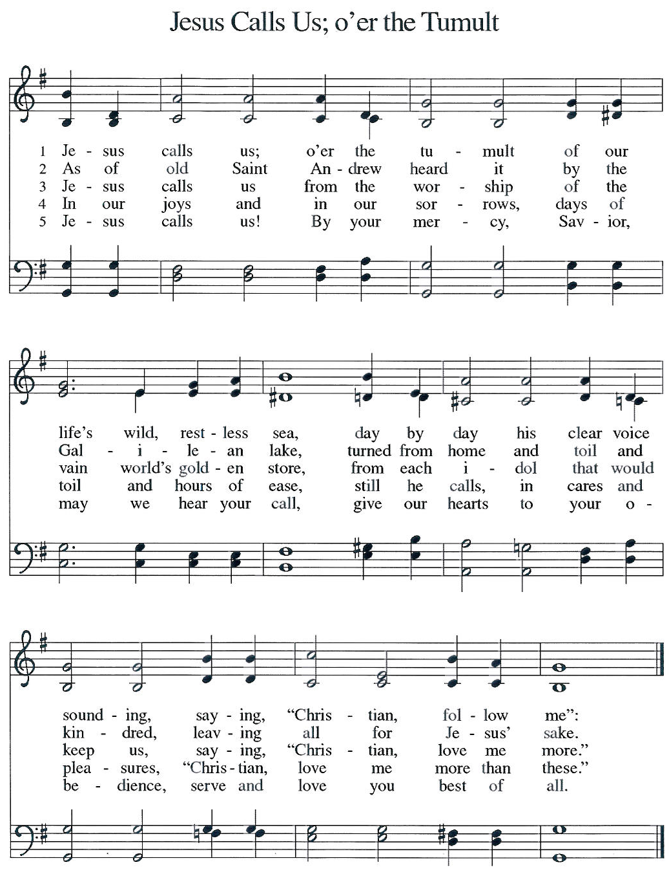
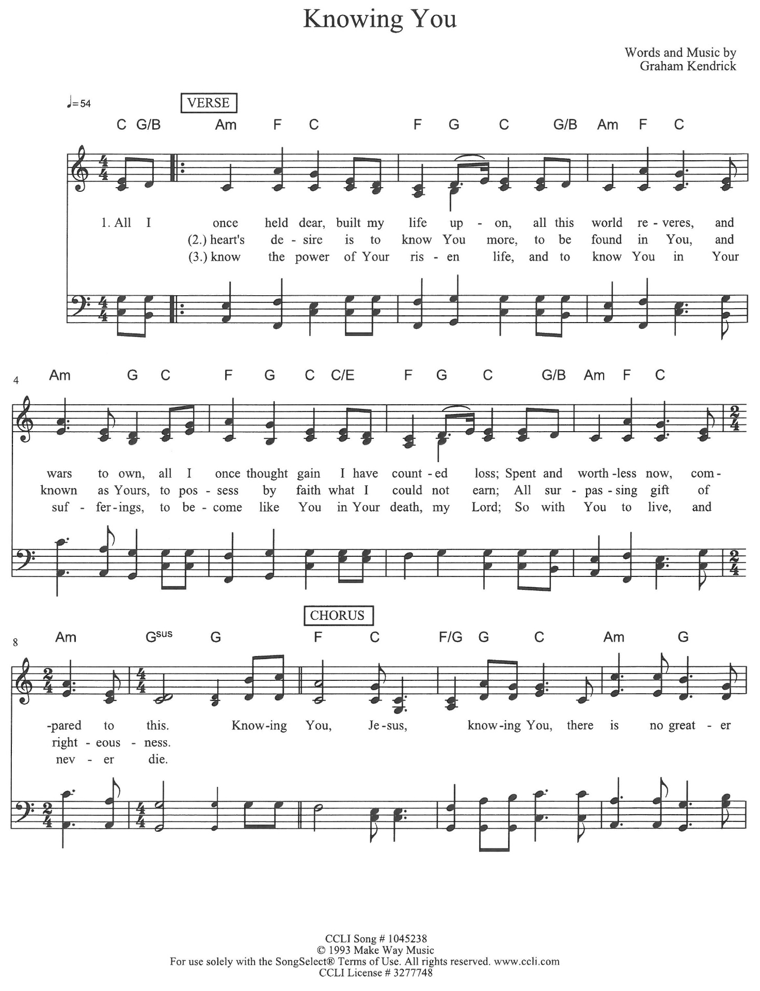

Blessing after Communion
Now may the body and blood of our Lord, Jesus Christ, strengthen you and keep you in his peace. Amen.

The Sending

Why does our church exist? What is our purpose?
We go out to transform lives through Jesus Christ.

Purpose Sightings

MILESTONES!
It's time for sharing milestones - a time where we join together as a community to share the big, small, good, and hard milestones in our life.

BLESSING
God bless you and keep you,
God smile on you and gift you,
God look you full in the face
and make you prosper.
Amen! Alleluia! Amen!

SENDING SONG “Mourning into Dancing”

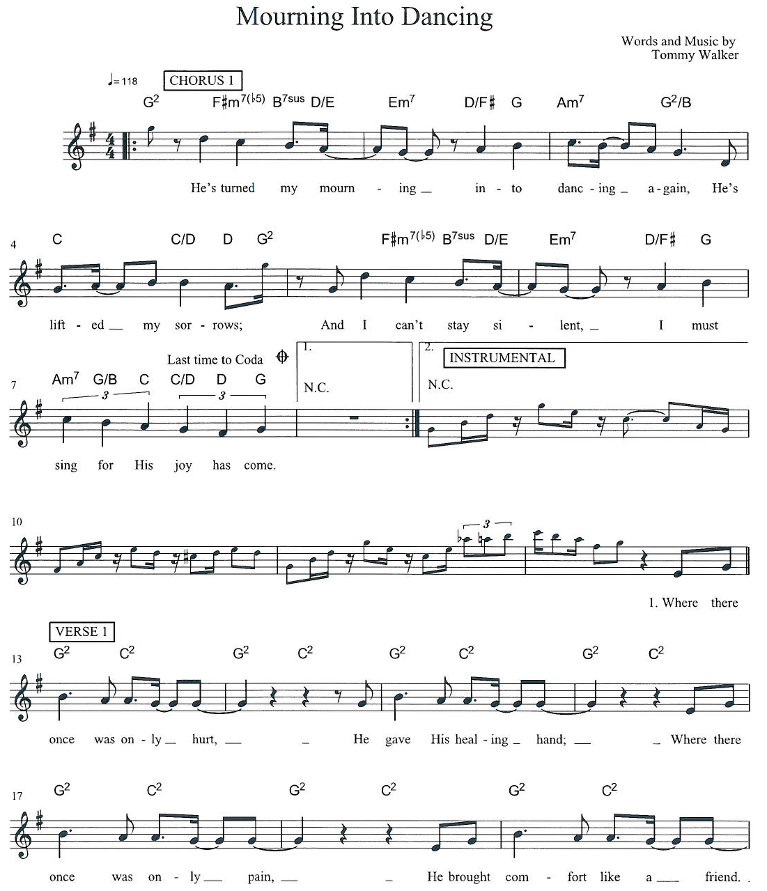

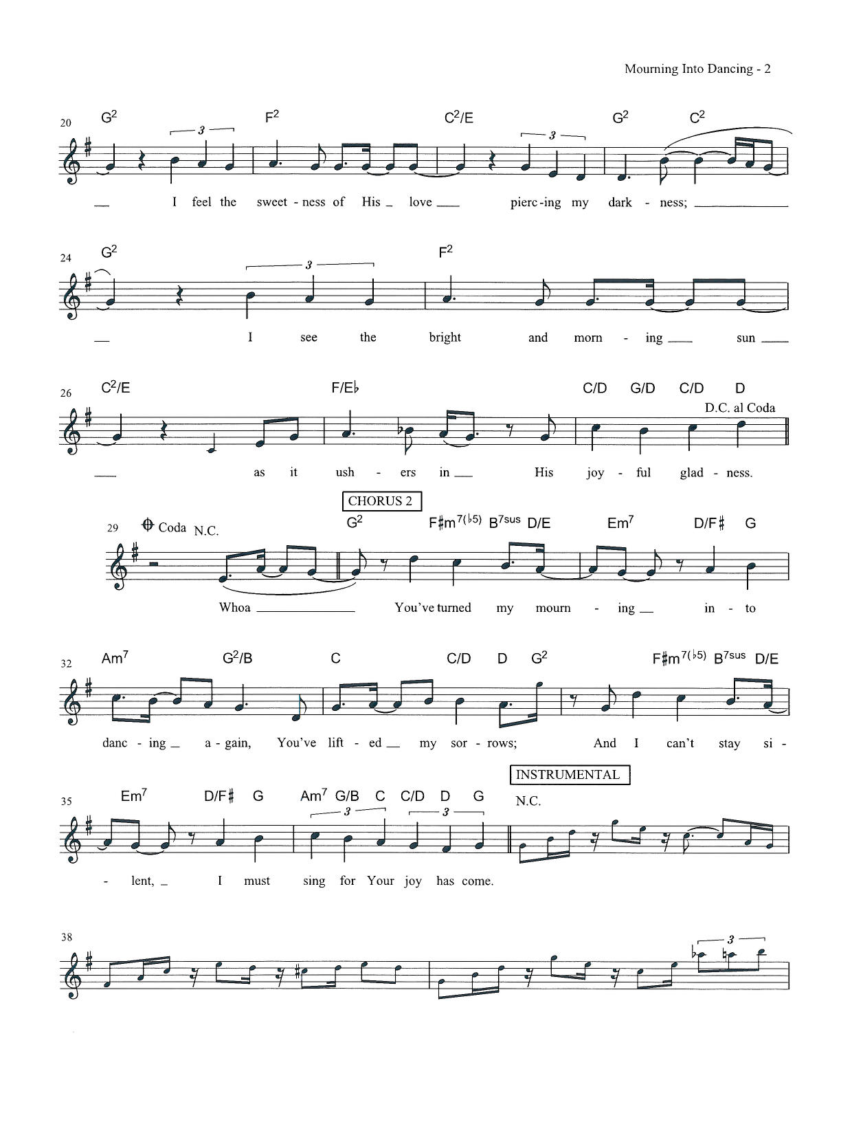
Go in peace, care for all creation.
Thanks be to God.

Music to Send You Out
From Sundays and Seasons.com. Copyright 2005 Augsburg Fortress. All rights reserved. Reprinted by permission under Augsburg Fortress Liturgies Annual License #SAS023086 CCLI License # 3277748 OneLicense.net license #A-726070

